Book

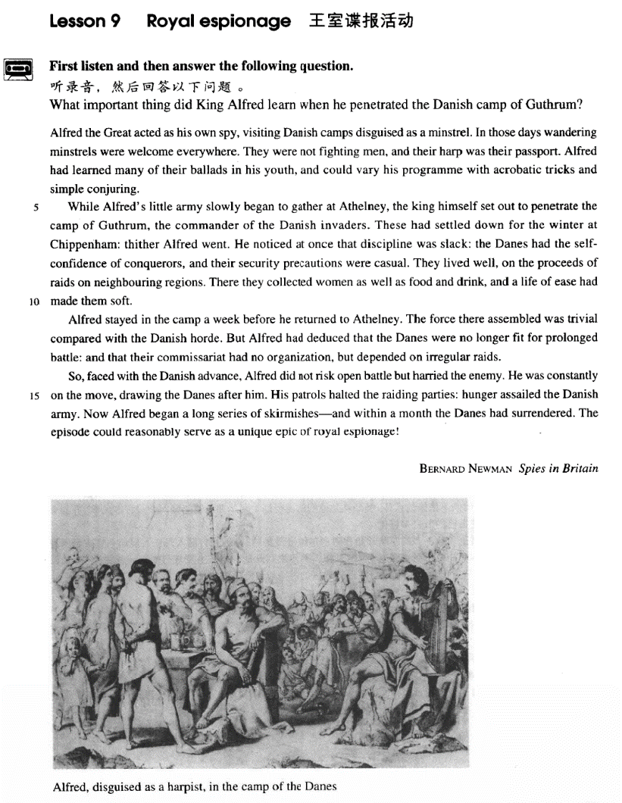

课文

Alfred the Great acted as his own spy, visiting Danish camps disguised as a minstrel.

阿尔弗雷德大帝曾亲自充当间谍，扮作吟游歌手到丹麦军队的营地里侦察。

In those days wandering minstrels were welcome everywhere.

当时，浪迹天涯的吟游歌手到处受欢迎。

They were not fighting men, and their harp was their passport.

他们不是作战人员，竖琴就是他们的通行证。

Alfred had learned many of their ballads in his youth and could vary his programme with acrobatic tricks and simple conjuring.

阿尔弗德年轻时学过许多民歌，并能穿插演一些杂技和小魔术使自己的节目多样化。

While Alfred's little army slowly began to gather at Athelney, the king himself set out to penetrate the camp of Guthrum, the commander of the Danish invaders.

阿尔弗雷德人数不多的军队开始在阿塞尔纳慢慢集结时，他亲自潜入丹麦入侵司令官古瑟罗姆的营地。

These had settled down for the winter at Chippenham: thither Alfred went.

丹麦军已在切本哈姆扎下营准备过冬，阿尔弗雷便来到此地。

He noticed at once that discipline was slack: the Danes had the self-confidence of conquerors, and their security precautions were casual.

他马上发现丹麦军纪律松弛，他们以征服者自居，安全措施马马虎虎。

They lived well, on the proceeds of raids on neighbouring regions.

他们靠掠夺附近的地区的财物过着舒适的生活。

There they collected women as well as food and drink, and a life of ease had made them soft.

他们不仅搜刮吃的喝的，而且抢掠妇女，安逸的生活已使丹麦军队变得软弱无力。

Alfred stayed in the camp a week before he returned to Athelney.

阿尔弗雷德在敌营呆了一个星期后，回到了阿塞尔纳。

The force there assembled was trivial compared with the Danish horde.

他集结在那里的军队和丹麦大军相比是微不足道的，

But Alfred had deduced that the Danes were no longer fit for prolonged battle: and that their commissariat had no organization, but depended on irregular raids.

然而，阿尔弗雷德断定，丹麦人已不再适应持久的战争，他们的军需供应处于无组织状态，只是靠临时抢夺来维持。

So, faced with the Danish advance, Alfred did not risk open battle but harried the enemy.

因此，面对丹麦人的进攻，阿尔弗雷德没有贸然同敌人作战，而是采用骚扰敌人的战术。

He was constantly on the move, drawing the Danes after him.

他的部队不停地移动，牵着敌人的鼻子，让他们跟着跑。

His patrols halted the raiding parties: hunger assailed the Danish army.

他派出巡逻队阻止敌人抢劫，因而饥饿威胁着丹麦军队。

Now Alfred began a long series of skirmishes -- and within a month the Danes had surrendered.

这时，阿尔弗雷德发起一连串小规模的进攻，结果不出一个月，丹麦人就投降了。

The episode could reasonably serve as a unique epic of royal espionage!

这一幕历史可以说是王室谍报活动中最精彩的篇章。

词汇讲解

Lesson 9 Royal Espionage

espionage ['espiənɑ:ʒ] n. 间谍活动

espionage n. [U] attempts to discover your enemy’s political, military, or industrial secrets using secret methods 间谍活动

counter-espionage spy secret agent mole

spy on ...

He was charged with spying on British military bases.

wandering ['wɒndərɪŋ] adj. 浪迹天涯的，居无定所的

a band of wandering musicians wander / roam

During a bullfight, a drunk suddenly wandered into the middle of the

ring.

have / take / go for a walk / stroll

He usually takes a short walk in the evenings and is always home by seven o'clock.

The idea never appealed to me very much, but one day, after a heavy shower, I happened to be walking in my garden when I noticed a huge number of snails taking a stroll on some of my prize plants.

walk the dog stretch one’s legs

You can stretch your legs on the spacious decks, play games, meet interesting people and enjoy good food …

stray

stray sheep

Only two stray dogs benefited from all this confusion, for they greedily devoured what was left of the cake. It was just one of those days!

conjuring ['kʌndʒərɪŋ] n. 变戏法，变魔术

conjuring / magic

conjure conjurer / magician The magician conjured a rabbit out of his hat.

abjure abjure one’s religion

adjure

I adjure you to tell the truth.

injure perjure (oneself)

The witness perjured himself.

thither ['ðɪðə(r)] adv. 去那里，到那里

thither hither

hither and thither = here and there

The leaves were blown hither and thither by the wind. Colored fish darted hither and thither.

slack [slæk] adj. 松弛的；懈怠的；萧条的

slack tight taut

Slack defending by Real Madrid allowed Manchester United to score. Business is bad / slack / depressed in winter.

the Great Depression Business is good / booming.

conqueror ['kɒŋkərə(r)] n. 征服者

William the Conqueror conquer

The Normans conquered England in 1066. I came, I saw, I conquered.

England conquered their main rivals in the first round.

conquer the mountain

I finally conquered my fear of heights.

She has conquered the hearts of many men.

precaution [prɪ'kɔ:ʃn] n. 预防措施

precaution n. sth. you do in order to prevent sth. dangerous from happening

fire / safety / security / sanitary precautions

take precautions

The government took precautions to prevent the spread of the disease.

take measures

take *effective* measures to do … take *drastic* measures to do …

caution cautious

cautious optimism about sth.

be cautiously optimistic about sth.

proceeds ['prəʊsi:dz] n. 收入，收益

proceeds: n. the money that is obtained from doing sth. or selling sth. proceeds *of / from* sth.

The proceeds *of* the concert will go to charity.

gain fame and gain profit proceedings

divorce proceedings proceed to do …

assemble [ə'sembl] v. 人群聚集；装配，组装

A large crowd assembled outside the American embassy.

A large crowd was assembled outside the American embassy.



assemble a computer dismantle / take apart

dismantle the computer take the computer apart

prolonged [prə'lɒŋd] adj. 持久的，长时间的

prolonged questioning prolonged exposure to the sun

prolong The drugs help to prolong life. protracted (protract)

protracted warfare = prolonged warfare

curtail curtail one’s holiday

episode ['epɪsəʊd] n. 插曲，片段，逸事

episode n. an event occurring as part of a long series of events, as in a novel, one’s life, etc.

one of the most interesting episodes in his career Please watch next week’s thrilling episode! the final episode

harry ['hæri] vt. 骚扰，纠缠

He was harried by journalists / phone calls. The Vikings harried the English coast.

harass harassment

sexual harassment

assail

I had no sooner got off the ship than I was assailed by a man who wanted to sell me a diamond ring.

pester

pester sb. for sth.

The beggar pestered me for money. pester sb. to do

From the moment he arrived there, he kept on pestering his doctor to tell him when he would be able to go home.

the royal palace

the Royal Air Force / Navy

royalty

a shop patronized by royalty

loyal loyalty

Alfred the Great acted as his own spy, visiting Danish camps *disguised as*

*a minstrel*.

Alfred (849~899): king of the West Saxons (871~899). He is one of the most outstanding figures of English history. He is the only ruler to resist Danish invaders, that is Vikings, successfully. Alfred made his kingdom the rallying point for all the Saxons, thus laying the foundation for the unification of England. He was recognized as the first king of England. Today his name still carries thunder: Alfred the Great.

历史人名+称谓/外号等

Peter the Great

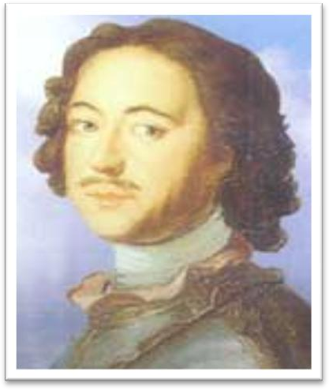

Alexander the Great

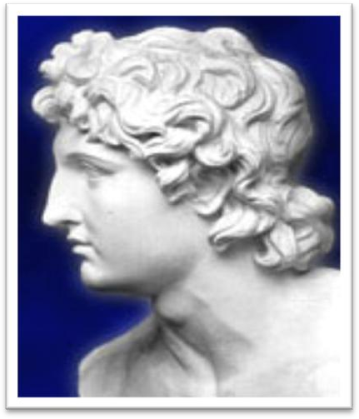

Caesar the Great

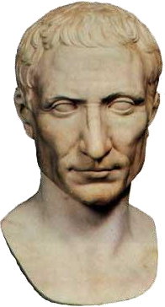Catherine the Great



Richard the Lion-hearted

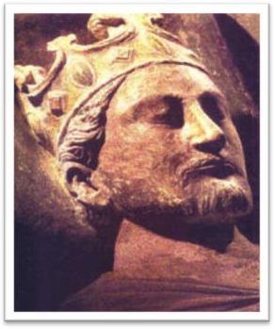

George the Fifth

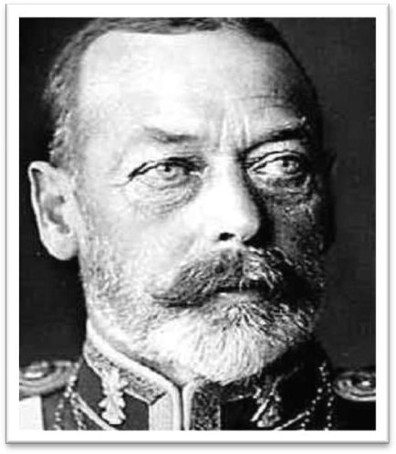

William the Conqueror



act as … 1. （临时）担任某工作

My brother speaks French—he can act as interpreter. act as … 2. 当做……来用

= be used as / serve as / function as

Not all sounds made by animals serve as language, …

disguise A as B

The king disguised himself as a peasant.

He escaped across the border disguised as a priest.

dress (sb.) up as …

The king dressed (himself) up as a peasant.

dressed up as …（非谓语）

Alfred the Great acted as his own spy, visiting Danish camps dressed up as a minstrel.

When a student recently saw two workmen using a pneumatic drill outside his university, he immediately telephoned the police and informed them that two students dressed up as workmen were tearing up the road with a pneumatic drill.

in those days

In those days, boxers fought with bare fists for prize money.

these days / today / nowadays

These days, people who do manual work often receive far more money than people who work in offices.

passport

British / Chinese passport visa

work / student / tourist visa

暗喻 Metaphor

1、喻体直陈式

College is a comma of a sentence of life. She was an angel of a wife.

2、喻体全隐式

As the time and cost of making a chip drop to a few days and a few hundred dollars, engineers may soon be free to let their imaginations soar without being penalized by expensive failures.

Some books are to be tasted, others to be swallowed and some few to be chewed and digested.

— Sir Francis Bacon

3、喻体半隐式

From every window heads were craning for a view of it．

He doesn’t have an idea of his own. He just parrots what other people say．

A heavy silence blanketed the room． They stormed the speaker with questions．

I would argue that although it may be a benefit to study classics and

be well schooled in diverse disciplines, these pursuits merely refine and hone an ability each and every person has, the ability to study human nature. *(GRE Issue Model Assay)*

in (one’s) youth

The reader's hair stands on end when he reads in the final pages of the novel that the heroine a dear old lady who had always been so kind to everybody, had, in her youth, poisoned every one of her five husbands.

I live in that solitude which is painful in youth, but delicious in the years of maturity.

— Albert Einstein To obtain the nutrients you need, vary the foods you eat. add variety to …

diversify …

add color / spice to …

This invariably wins them the love and respect of others, for they add color to the dull routine of everyday life.

While Alfred's little army slowly began to gather at Athelney, the king himself set out to penetrate the camp of Guthrum, the commander of

the Danish invaders.

little adj. trivial; insignificant

gather v. assemble; collect; mass; congregate … set out to do 1. begin a job / task

Dimitri at once set out to find the thief.

The journalist immediately set out to obtain these important facts, but he took a long time to send them.

set out to do 2. 有意做某事

We never set out to hurt you, Victor. And I'm sorry we did. Are you done?

Yeah.

True eccentrics never deliberately set out to draw attention to themselves.

penetrate (into / through) …

Our troops have penetrated (into) enemy territory.

trespass on …

I accused him of trespassing on my estate. Trespassers will be prosecuted.

Guthrum: Danish king, he was forced to accept baptism after being defeated by Alfred.

settle down

They’d like to see their daughter settle down, get married and have

kids.

Discipline is slack / loose / lax.

*security* precautions *safety* precautions *fire* precautions *sanitary* precautions

casual adj. slack; careless; inattentive

They lived well, on the proceeds *of raids on neighbouring regions*.

He lives on salary.

He lives on his parents.

proceeds: n. the money that is obtained from doing sth. or selling

sth.

proceeds *of / from* sth.

The proceeds *of* the concert will go to charity. a raid on a jeweler's shop

neighboring adj. nearby

as well as … 除了……之外还…… There they collected women

in addition to food and drink besides food and drink along with food and drink together with food and drink aside from food and drink apart from food and drink

There they collected not only food and drink but also women. If you appear to be soft, people will take advantage of you.

I shaved before I went to the party.

But I decided to disembark before buying anything.

强调主句的时间很长时，译为才

It will be a long time before we meet again.

Looking at his watch, he saw that it was one o'clock, but the bell struck thirteen times before it stopped.

强调主句的时间很短时，译为就

I hadn’t waited long before he came.

The force there assembled was trivial compared with the Danish horde.

The force (which was) assembled / gathered / massed there was trivial …

compared to / with …

in / by contrast to / with …

in / by comparison to / with …

But Alfred had deduced that the Danes were no longer fit for prolonged battle: and that their commissariat had no organization, but

depended on irregular raids. be fit for … / to do …

Chickens slaughtered in the United States, claim officials in Brussels,

are not fit to grace European tables.

not … but … 不是……而是…… not that …, but that …

不是因为……，而是因为……

Not that I love Caesar less, but that I love Rome more.

— Shakespeare ‘Julius Caesar’

So, faced with the Danish advance, Alfred did not risk open battle but harried the enemy.

be faced with …

be confronted with …

…when Alfred was faced with the Danish advance, …

risk sth. / doing

risk one’s life

risk being caught in a storm

Alfred harried the enemy

instead of risking open battle.

in preference to risking open battle. in place of risking open battle. rather than risked open battle.

She telephoned rather than wrote.

He is to be pitied rather than to be disliked.

on the + noun. 处于某种状态

The dog is on the alert. He is always on the go.

The patient is on the recovery. Crimes are on the rise.

Even people who take no interest in art cannot have failed to notice examples of modern sculpture on display in public places.

The house is on sale.

The workers are on strike. I’m here on vacation.

I’m here on business.

The nurse is on call 24 hours a day.

party n. group; band; team

The only regular visitors to the monastery in winter are *parties* of skiers who go there at Christmas and Easter.

a search party a rescue party

The Danish army suffered from hunger. Panic seized me.

Curiosity swallowed him. Confidence deserted him. That night sleep eluded me. Sunset met them halfway.

The past few years witnessed the great influx of foreigners to China, for travelling, studies or business.

reasonably adv. justifiably; legitimately

be unique to …

Each set of genes is unique to the individual. be peculiar to …

Pandas are peculiar to China.